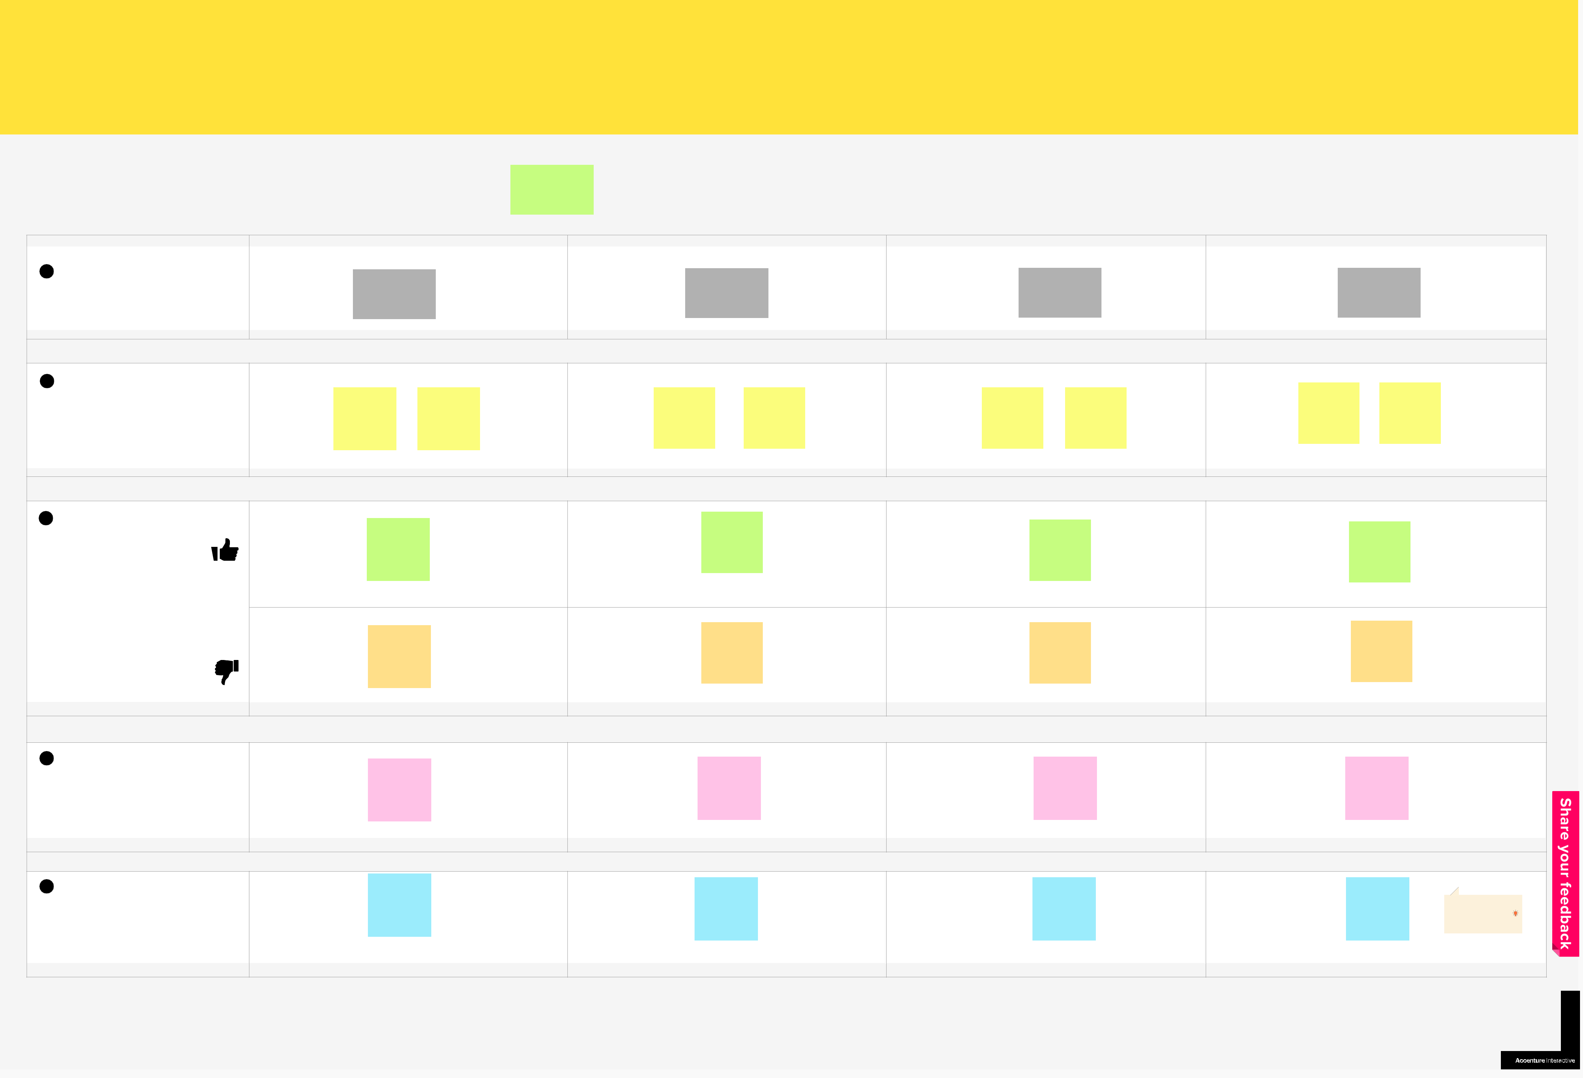
User journey

by the Design Team of Accenture Interactive NL

DONATE PLASMA USING THE PLAMA DONOR APPLICATION SYSTEM THAT IS USED TO ^{PLASMA} DONOR
CONNECT DONOR WHO IS INTERESTED TO DONATE PLASMA AND THE PATIENTS WHO | APPLICATION
WANTS PLASMA.
⏰

People Time Difficulty

2–9 30 min Beginner

Phases

High-level steps your user needs to

accomplish from start to finish

WHETHER THIS

APPLICATION IS

SUITABLE FOR ME

WHETHER

REQUESTS REACH

DONOR

PLASMA REACH

PATIENTS OR NOT

DONATING PLASMA

VIA THIS

APPLICATION IS SAFE

OR NOT

- Steps

Detailed actions your user has to perform

Y

REGISTER | UPLOAD THEIR
WITH THEIR | MEDICAL
DETAILS | DOCUMENTS

THE DONOR | PATIENTS
WAITS FOR | WANTS PLASMA
THE MAIL | THEY SEARCH
TO DONATE | AND FIND
PLASMA | DONORS

ASK THE USER | TRY THE
TO GIVE | APPLICATION
REVIEWS | AND GET TO
 | KNOW ABOUT
 | IT

EXPLORE IN | MAINTAIN
THE WEB | THEIR
ABOUT | BODY TO
SIMILAR | DONATE
APPLICATION | PLASMA

- Feelings

What your user might be thinking and feeling at the moment

 | CHECK WITH THE |  | EXCITED TO | GETTING
EXCITED TO | REVIEWS | GIVEN | EXCITED TO | GETTING
 |  |  |  | EXITED ABOUT
EXCITED TO | BY THE | USERS |  | EXITED ABOUT
KNOW ABOUT | BY THE | USERS |  | THE
KNOW ABOUT | ANDGET EXCITED |  | VIEW THE | THE
THE WORKING | ABOUT THE |  |  | DONATION OF
OF THE NEW | APPLICATION |  | LOCATION OF | PLASMA
SYSTEM |  |  | PATIENT

 |  | COMING |  | ARE THE | WHAT IF THE
SUSPICIOUS |  | ACROSS BAD |  | ARE THE | WHAT IF THE
SUSPICIOUS |  | ACROSS BAD |  | DETAILS | LOCATION OF
ABOUT THE |  | REVIEWS AND |  | DETAILS | PATIENT IS
ABOUT THE |  | GET |  | SECURE | PATIENT IS
APPLICATION |  | GET |  | SECURE | NOT CORRECT
APPLICATION |  | RESENTED |  |  | NOT CORRECT

Pain points

Problems your user runs into

SUSPECIOUS

ABOUT THE

APPLICATION

LOSS OF

PHYSICAL

BODY

HEALTH

DEPRESSED,

AFTER

DONATING

PLASMA

DONATING

PLASMA IS

PAINFUL

Opportunities

Potential improvements or

enhancements to the experience

GET TO

EXPLORE

VARIOUS HELP

GIVEN BY THE

APPLICATION

TO THE USER

GET TO

EXPLORE

VARIOUS HELP

GIVEN BY THE

APPLICATION

TO THE USER

DONATE

PLASMA TO

THE

PATIENTS

PEOPLE CAN GET

THE SERVICES

THROUGH

ONLINE ON

THE APPLICATION

TIP

Click on the + outside the
border of the table to add
additional rows and columns.

